SOFTWARE REQUIREMENTS SPECIFICATION

**For**

**Airline Reservation system**

**Prepared by:-**

Dharun D

Boopesh M

Senthamizh selvan K

# Introduction

## Purpose

## The purpose of an airline reservation system is to streamline and enhance the entire process of air travel for both passengers and airlines. Serving as a sophisticated and computerized platform, this system facilitates the efficient booking and management of flight reservations. For passengers, it provides a user-friendly interface to search for available flights based on various criteria such as dates, times, and destinations. It enables the selection and reservation of specific seats, as well as secure online payment for booking confirmation.

## Document Conventions

* + - Entire document should be justified.
    - Convention for Main title

Font face: Times New Roman Font style: Bold

Font Size: 14

* + - Convention for Sub title

Font face: Times New Roman Font style: Bold

Font Size: 12

* + - Convention for body

Font face: Times New Roman Font Size: 12

## Scope of Development Project

The development of an airline reservation system represents a substantial and impactful project with a broad scope, encompassing various facets that contribute to the optimization of air travel services. The scope of this development project extends from enhancing user experience to ensuring operational efficiency and compliance with industry standards.

The scope extends to the implementation of emerging technologies, such as blockchain for enhanced security and augmented reality for immersive experiences. Collaborations with travel partners, loyalty program integrations, and the provision of ancillary services like travel insurance contribute to the system's versatility and competitiveness in the market.

## Definitions, Acronyms and Abbreviations

SRS -> Software Requirement specification

WWW -> World Wide Web

MySQL

RDBMS -> Relational DataBase Management System

HTML -> Hypertext Markup Language

PHP-> Hypertext Preprocessor

CSS -> Cascading Style Sheets

HTTP -> Hypertext Transfer protocol

## References

* + - Books

 Software Requirements and Specifications: A Brief Guide to the Standard Object Modeling Language" by Martin Fowler

Software Requirements (Microsoft) Airline Operations and Scheduling" by Massoud Bazargan

Software Engineering: Principles and Practice" by Hans Van Vliet

* + - Websites

[**http://www.slideshare.net/**](http://www.slideshare.net/)

**https://www.oneclickitsolution.com/blog/airline-reservation-system/**

# Overall Descriptions

## 2.1Product Perspective

Use Case Diagram of Airline Reservation System

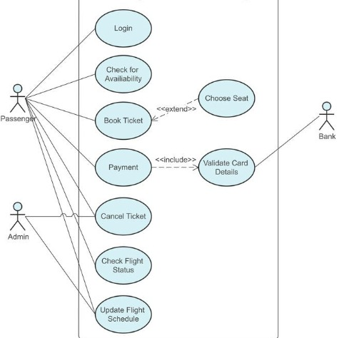

This is a broad level diagram of the project showing a basic overview. The users can be either staff or student.. This System will provide a search functionality to facilitate the search of resources. This search will be based on various categories viz.

.

## Product Function

Entity Relationship Diagram of Airline Reservstion System

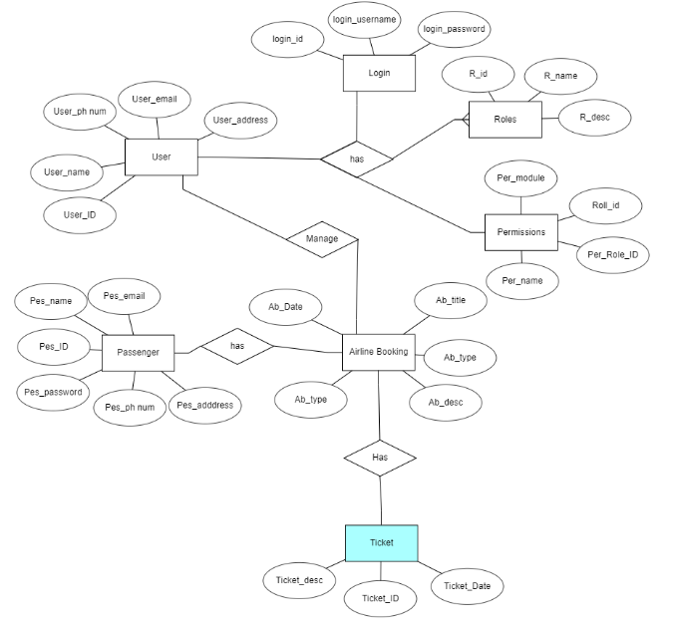 An airline reservation system (ARS) is a crucial software facilitating seamless air travel booking. The system offers a user-friendly interface for flight searches, seat selections, and secure transactions through integrated payment gateways. It provides real-time flight information, confirmation emails, and allows users to modify or cancel reservations. Admin functionalities include flight management, user administration, and analytics. Robust security measures, such as encrypted data transmission, ensure user information safety.

## User Classes and Characteristics

Airline reservation systems (ARS) are systems that allow an airline to sell their inventory (seats). It contains information on schedules and fares and contains a database of reservations (or passenger name records) and of tickets issued (if applicable)

The features that are available to the Airline reservation are:-

* + - User properties like Name, Address, Age,

1. Flight properties like Departing/Arriving City, Departure/Arrival dates and times, Miles, and an
2. identifying Flight Number.
3. Flight properties like Departing/Arriving City, Departure/Arrival dates and times, Miles, and an
4. identifying Flight Number.
5. Flight properties like Departing/Arriving City, Departure/Arrival dates and times, Miles, and an
6. identifying Flight Number.
7. Flight properties like Departing/Arriving City, Departure/Arrival dates and times, Miles, and an
8. identifying Flight Number.
9. Flight properties like Departing/Arriving City, Departure/Arrival dates and times, Miles, and an
10. identifying Flight Number.
11. Flight properties like Departing/Arriving City, Departure/Arrival dates and times, Miles, and an
12. identifying Flight Number.
    * + Associated with Flight Miles accumulated and Credit Card information.
      + Flight properties like Departing/Arriving City, Departure/Arrival dates and times, Miles, and an identifying Flight Number.
      + Flight Seat properties of identifying seat number, reserved and flight

Associated to Flight by flight numberCan take the book returned from students

The features that are available to the passengers are:-

* + - Highly Customizable System
    - Fast and error-free online reservation facility
    - Multi-city search option
    - Reservation Management
    - Inventory Management
    - Payment gateway integration
    - Mobile-friendly design

## Operating Environment

## The operating environment of an airline reservation system (ARS) refers to the hardware, software, and network infrastructure that supports the functioning of the system. It encompasses various components that work together to facilitate the reservation and booking processes for airlines.

## Assumptions and Dependencies

The assumptions are:

* Real-Time Availability
* Network Connectivity
* Secure Transactions
* Regulatory Compliance
* Accurate Fare Calculations

The dependencies are:-

* Accurate Fare Calculations
* Flight Inventory Database
* Payment Gateways
* Network Infrastructure
* Airline Inventory System

## Requirement

Software Configuration:-

This software package is developed using java as front end which is supported by sun micro system. Microsoft SQL Server as the back end to store the database.

Operating System: Windows NT, windows 98, Windows XP Language: Java Runtime Environment, Net beans 7.0.1 (front end) Database: MS SQL Server (back end)

Hardware Configuration:-

Processor: Pentium(R)Dual-core CPU Hard Disk: 40GB

RAM: 256 MB or more

## Data Requirement

## An airline reservation system requires comprehensive data, including flight schedules, seat availability, passenger details, and pricing information. Additionally, it relies on real-time updates for managing bookings, cancellations, and modifications. A centralized database is essential for storing critical data, ensuring seamless coordination between various components, and facilitating secure online transactions.

# External Interface Requirement

## GUI

## The graphical user interface (GUI) for an airline reservation system plays a crucial role in providing a user-friendly experience for both customers and airline staff. Here are key components and features commonly found in the GUI for an airline reservation system

## Flight Search:

## User-friendly search forms allowing passengers to input travel details, such as origin, destination, dates, and preferences.

## Flight Selection:

## Clear presentation of available flights with details on departure/arrival times, airlines, and prices.

## Seat Selection:

## Interactive seat maps allowing passengers to choose and visualize their preferred seats.

## User Authentication:

## Secure login and registration interfaces for passengers and airline staff, ensuring data privacy.

Login Interface:-

In case the user is not yet registered, he can enter the details and register to create his account. Once his account is created he can ‘Login’ which asks the user to type his username and password. If the user entered either his username or password incorrectly then an error message appears.

Search:-

The passenger can enter the type of flight he is looking for and the type of seat he is interested in,then he can search for the flight by entering the date when he is boarding.

Categories View:-

Categories view shows the categories of seats available and provides ability to the passenger to choose category from the list.

Passenger’s Control Panel:-

The passenger control panel in an airline reservation system provides users (passengers) with a set of tools and functionalities to manage their bookings, preferences, and other aspects related to their travel.

# System Features

The users of the system should be provided the surety that their account is secure. This is possible by providing:-

* User authentication and validation of passenger’s using their unique member ID
* Proper monitoring by the administrator which includes updating flight schedule, showing a popup if the passenger attempts to issue board the flight.
* Proper accountability which includes allowing a passenger to see flight duration and available dates.

# Other Non-functional Requirements

## Performance Requirement

Performance requirements for an airline reservation system (ARS) are critical to ensure that the system operates efficiently, responsively, and reliably. Here are key performance requirements for an airline reservation system:

* Establish the number of transactions the system should process per unit of time to meet peak demand and ensure smooth operations during busy periods.
* Define how the system should scale to handle increased loads. This includes horizontal scalability to add more servers and resources during peak times.
* Set expectations for network latency to ensure that data can be transferred quickly between different system components, especially in distributed architectures.

## Safety Requirement

The safety requirements of an airline reservation system (ARS) are crucial to ensure the integrity, confidentiality, and availability of data, as well as the overall security of the system.

## Security Requirement

* System will use secured database
* Normal users can just read information but they cannot edit or modify anything except their personal and some other information.
* System will have different types of users and every user has access constraints
* Proper user authentication should be provided
* No one should be able to hack users’ password

## Requirement attributes

* There may be multiple admins creating the project, all of them will have the right to create changes to the system. But the members or other users cannot do changes
* The project should be open source
* The Quality of the database is maintained in such a way so that it can be very user friendly to all the users of the database
* The user be able to easily download and install the system

## Business Rules

A business rule is anything that captures and implements business policies and practices. A rule can enforce business policy, make a decision, or infer new data from existing data.This includes the rules and regulations that the System users should abide by. This includes the cost of the project and the discount offers provided. The users should avoid illegal rules and protocols. Neither admin nor member should cross the rules and regulations.

## User Requirement

User requirements for an airline reservation system are essential to ensuring that the system meets the needs and expectations of its users. These users can include passengers, airline staff, administrators, and other stakeholders. Here are some common user requirements for an airline reservation system:

The admin provides certain facilities to the users in the form of:-

* Backup and Recovery
* Forgot Password
* User Authentication
* A user-friendly interface for easy navigation
* Auto Recovery i.e. frequently auto saving the information
* Maintaining files i.e. File Organization
* The server must be maintained regularly and it has to be updated from time to time

# Other Requirements

## Data and Category Requirement

## An airline reservation system requires passenger data such as names, contact information, and travel preferences. Additionally, it needs real-time flight data, including schedules, availability, and pricing. Secure storage of payment details and compliance with privacy regulations are critical for customer data protection. Efficient processing relies on accurate and up-to-date information to facilitate booking, check-in, and overall travel management.

## Appendix

A: Admin, Abbreviation, Acronym, Assumptions ; C: Class, Client, Conventions; D: Data requirement, Dependencies; G: GUI; K: Key; N: Non-functional Requirement; O: Operating environment; P: Performance,Perspective,Purpose,passenger; R: Requirement, Requirement attributes; S: Safety, Scope, Security, System features; U: User, User class and characteristics, User requirement;

## Glossary

The following are the list of conventions and acronyms used in this document and the project as well:

* Administrator: A login id representing a user with user administration privileges to the software
* User: A general login id assigned to most users
* Passenger: Intended users for the software
* SQL: Structured Query Language; used to retrieve information from a database
* SQL Server: A server used to store data in an organized format
* Layer: Represents a section of the project
* User Interface Layer: The section of the assignment referring to what the user interacts with directly
* Application Logic Layer: The section of the assignment referring to the Web Server. This is where all computations are completed
* Data Storage Layer: The section of the assignment referring to where all data is recorded
* Use Case: A broad level diagram of the project showing a basic overview
* Class diagram: It is a type of static structure diagram that describes the structure of a system by showing the system’s cases, their attributes, and the relationships between the classes
* Interface: Something used to communicate across different mediums
* Unique Key: Used to differentiate entries in a database

## Class Diagram

A class is an abstract, user-defined description of a type of data. It identifies the attributes of the data and the operations that can be performed on instances (i.e. objects) of the data. A class of data has a name, a set of attributes that describes its characteristics, and a set of operations that can be performed on the objects of that class. The classes’ structure and their relationships to each other frozen in time represent the static model. In this project there are certain main classes

which are related to other classes required for their working. There are different kinds of relationships between the classes as shown in the diagram like normal association, aggregation, and generalization. The relationships are depicted using a role name and multiplicities..

